(Approx. 769 words)

Cheaper to Buy than Build?
By David Kretchmar, Hardware Technician
Sun City Summerlin Computer Club
https://www.scscc.club
dkretch (at) gmail.com

Many experts suggest you replace a computer about every six years. Usually, by the time a computer is six years old, it is nearing the end of its useful life or at least is in danger of becoming unreliable. At some point in our relationship with any computer, the machine will slow and begin to test our patience. Unfortunately, users will often tolerate a system’s sluggishness for far too long rather than deal with the hassle of setting up a new computer, even if they can reasonably afford a new system.

Users who like to stay on the bleeding edge of hardware technology will replace their systems every couple of years, but many do not believe in paying up to have the latest and greatest hardware. For most users, the “sweet spot” is hardware that has been out for at least a couple of years. After that, the price has usually dropped substantially, and any bugs have usually been discovered and worked out.

Since I use my computer for Virtual Reality gaming (for the grandkids, of course) and I like a fast computer, I tend to “overbuild.” As a result, I invest in hardware well above the minimum recommended specifications for my operating system, which has always been the latest version of Windows.

Better hardware should support a computer life span well above six years, possibly with some upgrades along the way. But no matter what, I usually notice some performance degradation before six years. “Not responding” notifications not caused by program bugs but by a lack of system resources will start to appear, and the computer will lose the snappy responsiveness that a good system should deliver.

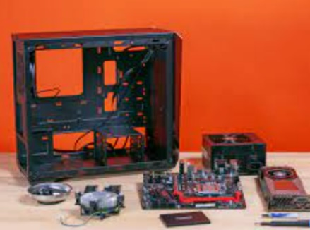
So, it was time to replace my six-year-old computer. Since 2001 I have enjoyed building my computer system from scratch. Building from scratch or “rolling your own” in the language of computer geeks allows you to select each component individually and avoid the no-name components used by many computers assembled for the general market. Third-party computer builders and sellers such as HP or Dell often use name-brand components for key items such as the CPU, at least in part for advertising purposes, but then skimp on other vital parts such as the motherboard and power supply (PSU). This results in a computer that might appear to have decent specs but will be barely adequate in the future and likely not be upgradeable.

In addition to having a faster, more reliable, longer-lived computer, I have saved substantial money by building it myself. But in 2022, the new computer landscape has changed. Buying a computer assembled by at least one manufacturer, Cyber Power, resulted in an excellent system that saved me about $300, or about 30%, compared to buying the individual components and assembling a system. Plus, it was a lot less work both shopping and assembling! In addition, I found that Cyber Power used individual quality components, most of which I would have chosen myself. Of course, other third-party builders also offer a similar advantage today, but Cyber Power offered the most dramatic savings.

This is the pre-built system I bought:

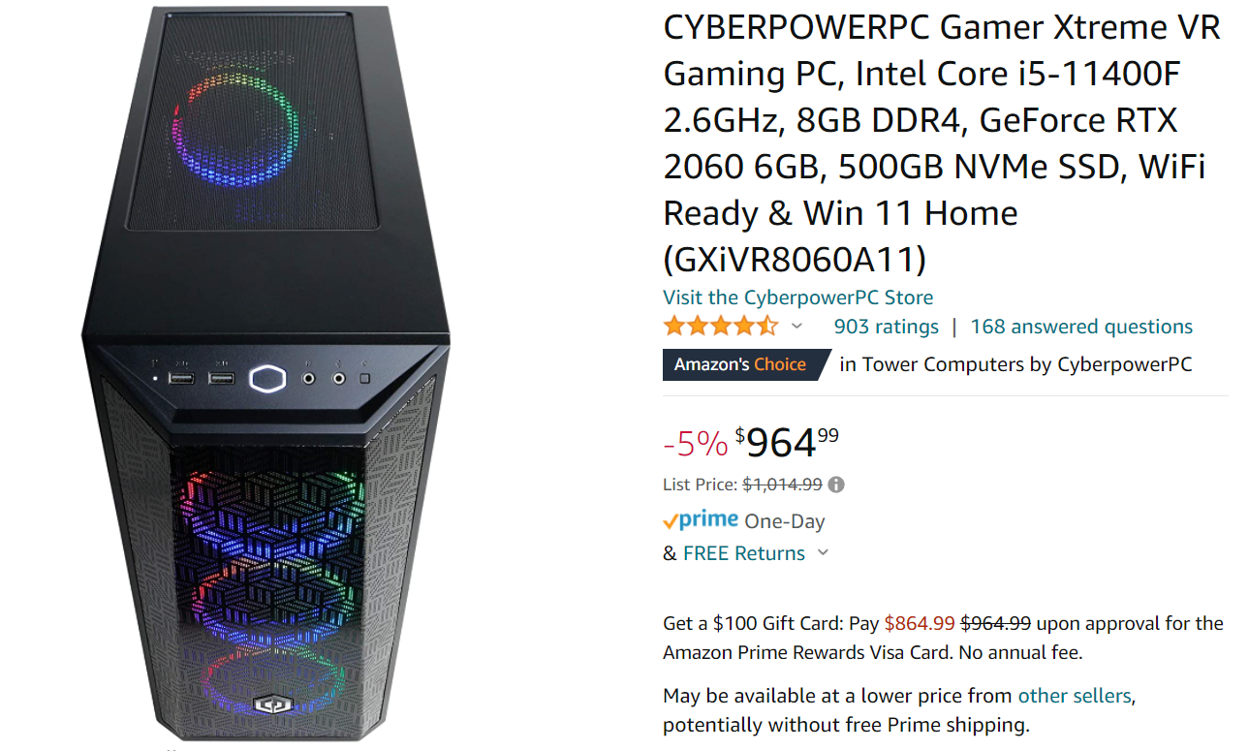

https://www.amazon.com/dp/B09DHP9M9G?psc=1&ref=ppx_yo2_dt_b_product_details

This is my analysis of the cost of buying each component individually:

- Intel Core i5-11400F 2.6GHz $170

- 8GB DDR4 RAM $ 30

- GeForce RTX 2060 6GB video card $620

- 500GB NVMe SSD, $70

- Gigabyte b560 ds3h ac MB $120

- 600 W PSU $ 60

- Windows 11 Home $130

- Case $80

- Total $1280

I shopped around for the components and attempted to find the best price for each one. I did not include sales tax or shipping for the pre-built system or the components.

My only issue with the pre-built system is the RAM; 8 GB of memory is just standard in 2022. Today 16 GB, 24 GB, and even 32 GB of RAM is what you would expect on a more powerful, somewhat future-proof computer. Fortunately, my old system has 16 GB of decent RAM, so I can beef up the RAM to 24 GB at no additional cost.

Conclusion

It is possible to buy a quality pre-built computer for the first time in memory for substantially less money and trouble than buying and assembling a system yourself. Some of this might result from supply chain issues, including video card availability and pricing. Today video cards are necessary for mining cryptocurrencies and other developing applications such as self-driving cars and other forms of Artificial Intelligence so that the demand will continue into the foreseeable future.

Images were copied from Google and Amazon.

